Sprint 1

Date | 1 November 2022
TEAM ID | PNT2022TMID04063
Project Name | IoT Based smart crop Protection system for agriculture
Maximum mark | 20 marks

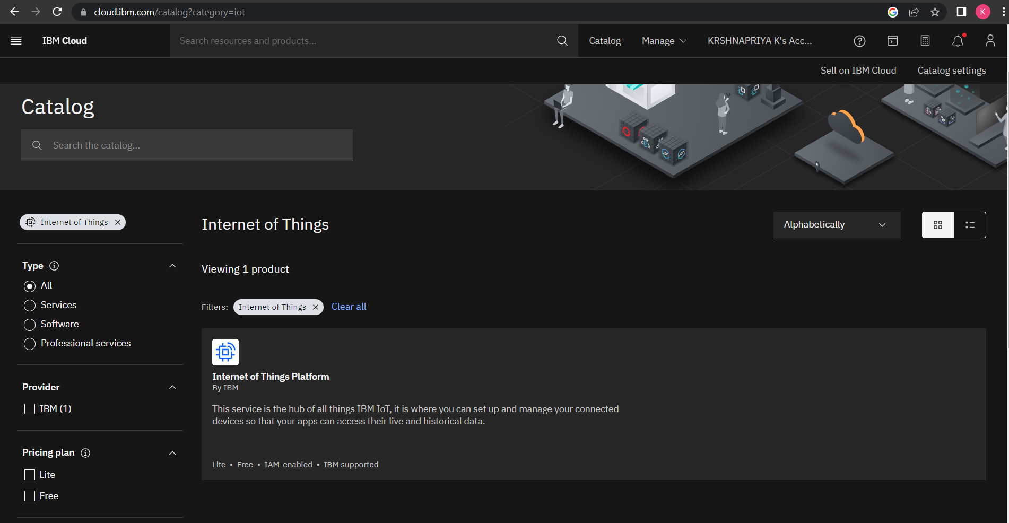

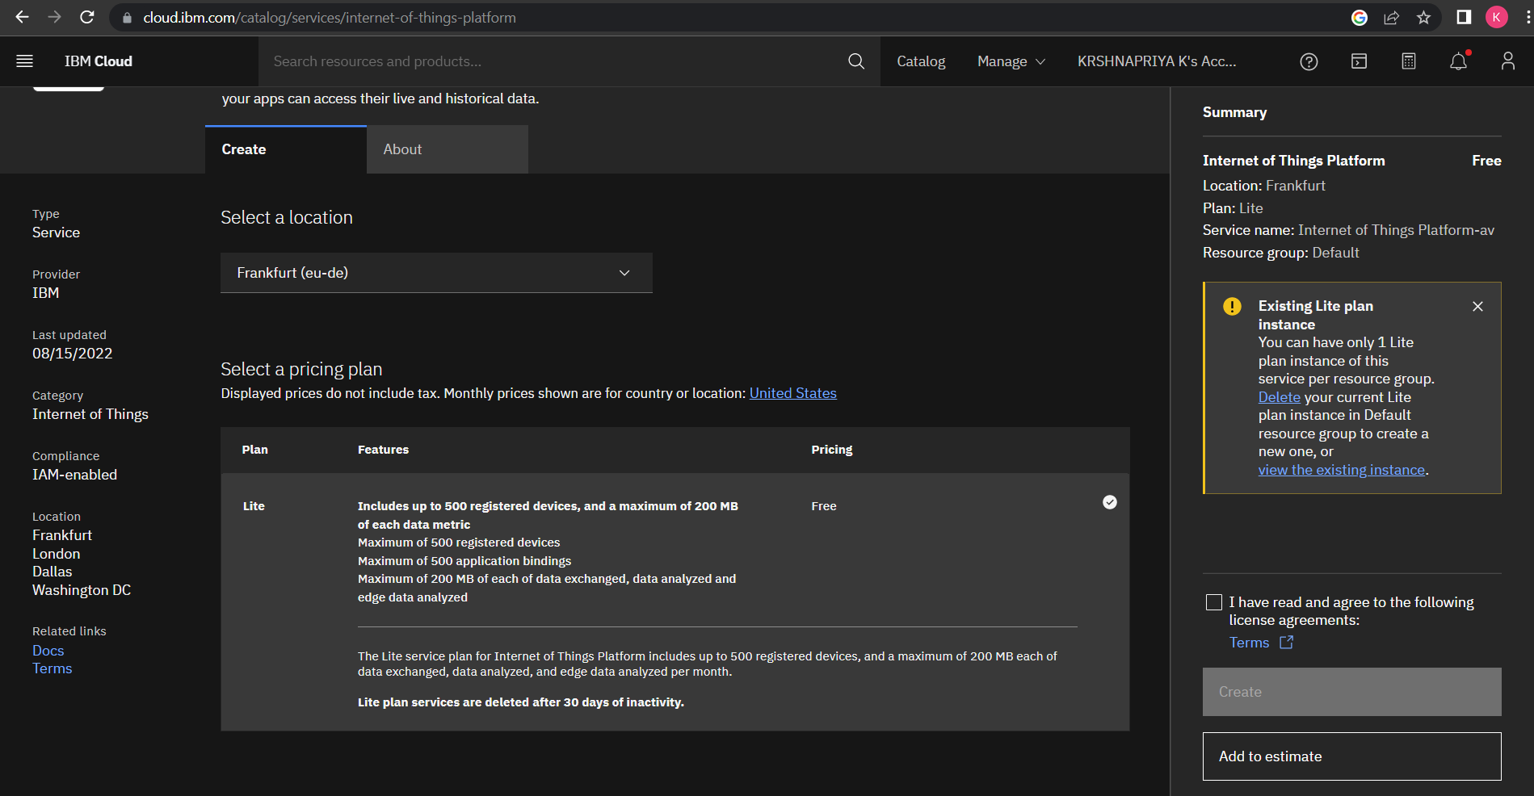

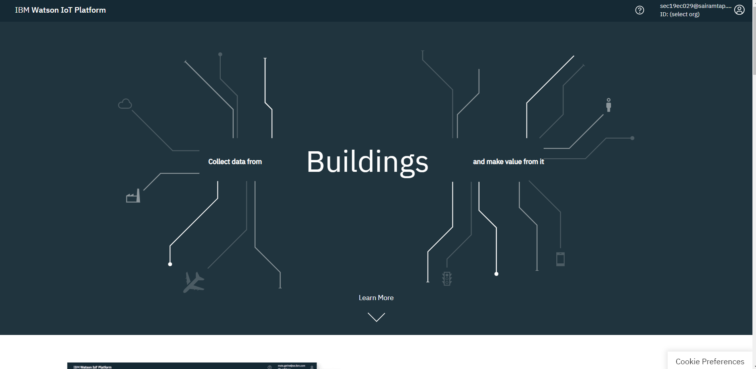

Device credentials information

